**Remote Work & Mental Health Analysis**

# 1.) Mental Health Condition of Employees

**Query: Result: 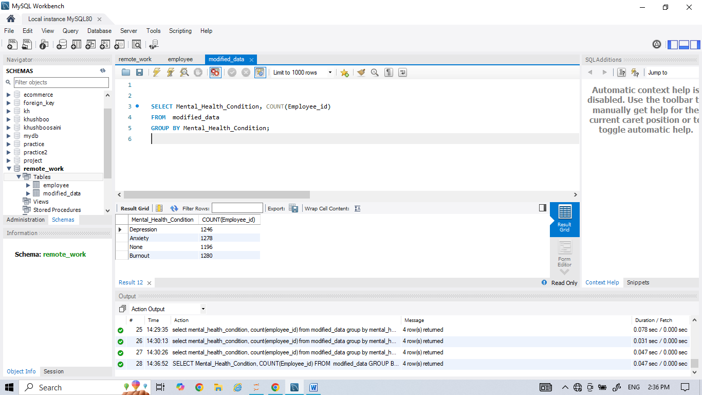 **

# 2.) Access to Mental Health Resources

# Query:

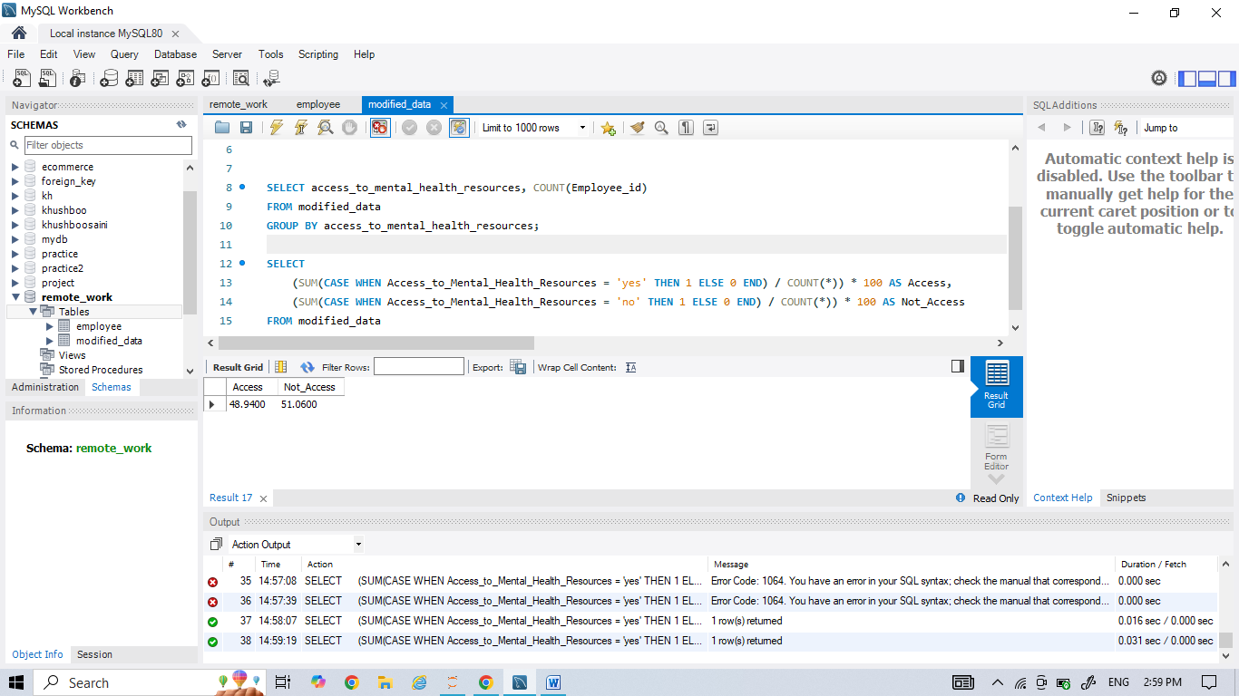

# Result:



# 3.) Stress Level by Work-Life Balance rating

# Query: Result:

# 

# 4.) Stress Level vs Age & Gender

# Query: Result:

# 5.) Hours Worked Per Week vs Stress Level

# Query:

# 

# Result:

# 

# 6.) Job Role vs Work Life Balance Rating

# Query: Result:

# 7.) Satisfaction with Remote Work by Work Location

# Query:

# Result:

# 

# 8.) Satisfaction with Remote Work by Access to Mental Health Resources

# Query:

# 

# Result:

# 

# 9.) Job Role vs. Work Life Balance Rating by Industry

# Query:

# Result:

# 